Science + Maths = solution

In Soho in London in 1854,a pioneering doctor called John Snow, put to good use his passion for mathematics when it came to the many outbreaks of disease which occurred in London at that time.

In those days, people believed that illness was spread through what they called ’miasma’, or bad air which wafted around making people sick. At that time many people died because of frequent outbreaks of a disease called Cholera.
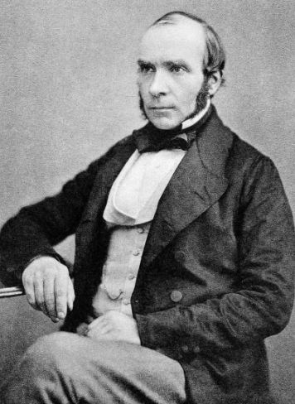
John Snow did not believe in the notion of bad air so dotted a map to show the areas in which people had been dying within the city. This revealed clusters of cases. He went to investigate one cluster in Soho and found, at it’s centre, one particular water pump which hundreds of people used every day. The water to this pump had become mixed up with sewage,which was the cause of the disease.

After identifying the source of the infection, Dr. Snow persuaded the council to remove the handle from the pump so that nobody could access water there. The number of cases fell dramatically to almost zero.

Preventing the spread of Cholera in the area was largely successful in that the number of deaths dropped significantly. The simple act of removing the pump handle saved an untold number of lives.

A logical approach to the problem had destroyed the superstition around miasma and replaced it with an innovative focus on science and mathematics. The combination of the two certainly curtailed the number of deaths. However, the cause of the disease, the contamination by sewage within the water source, was not addressed.
Local councils were reluctant to tackle this as it would cost too much money. It would be years later that they were forced to deal with London’s massive sewage problem.

John Snow is regarded as the founder of epidemiology, the study of the spread of disease. He is remembered in Broadwick Street in Soho where his pump still stands opposite a pub which has been named after him. The blue plaque on his house names him as the founding father of epidemiology.

How is mathematics helping us to deal with the outbreak of the Coronavirus globally?

Is preventing the spread of a disease more important than finding a cure?

Which should the experts focus on first?

Is it possible to prioritise one over the other?

