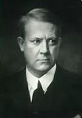
P4C

How important is your name to you?

During World War 2, a man called Vidkun Quisling headed the Norwegian government during the occupation of the country by Nazi Germany.

He was leader of the Norwegian Nazi Party and made plans with the Germans for them to invade his own country. By so doing, he knew that many Jewish people within Norway would be rounded up and killed.

Vidkun Quisling collaborated with the Germans against his own country, an action that saw him charged with high treason and murder. He was executed in October 1945 after the war had ended.

His actions caused his name to become synonymous with the word traitor and to this day, people can be referred to as a ‘Quisling’ if they have been caught out in an act of betrayal.

Think about the careful thought given by your parents when they choose a name for you at birth and then reflect on the actions of Vidkun Quisling whose name came to be held in such contempt.

How would you want people to remember your name – as belonging to someone who was kind and generous, someone brave or someone who worked hard at everything you did…

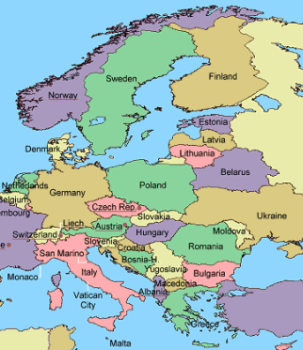
How much does your name mean to you? Were you named after a family member from the past? Does the honour of your name matter to you? Why ? Would it matter to you if your name was used to refer to negative actions or behaviour as Quisling’s was?

