Phonics Activity 5th -7th May 2020
Hello boys and girls. We hope you are well. For the next 3 days we would like you to log onto the phonics play website at this address https://new.phonicsplay.co.uk/resources/phase/2/buried-treasure and play the Buried treasure game. This game will help you to practise the sounds you have learned from watching the videos each day this week. Choose phase 3 and practise reading words with the following sounds each day. Remember to put the nonsense words in the trash. A nonsense word is a word that sounds strange and one that you probably don’t use when you are talking or writing.
Tuesday 5th May-/ow/
Wednesday 6th May- /oi/
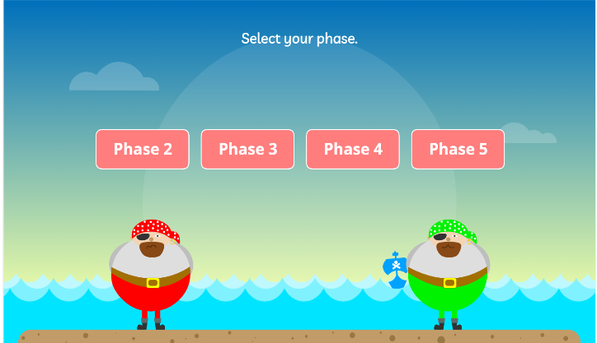
Thursday 7th May- /th/
