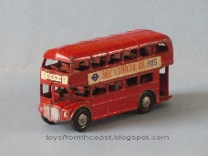
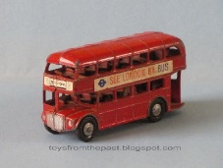
Write a letter to the Naughty Bus

Hello Boys and Girls. That little bus sure was naughty in our story wasn’t he? I think he is still learning the rules about how to behave properly in the house. Maybe he needs a little help to think about his behaviour from you boys and girls. So today, your teachers think it would be a good idea to write a letter to the naughty bus and ask him why he is being naughty. Maybe you could give him some help and advice about how he could be good. For example you might want to tell him that he should sit still at the table. Or maybe tell him he should not go too close to the pond. Don’t forget to start your letter with the words ‘To the Naughty Bus’ and finish your letter with ‘Love from…’ Remember to start your sentences with a capital letter, leave finger spaces between each word and end your sentences with a full stop.

Parents - Your child may spell naughty as ‘nortee’ or table as ‘taibl.’ This is great and should not be corrected. They are using their knowledge of phonics to sound out unfamiliar words.

