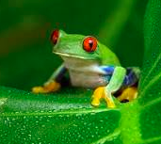
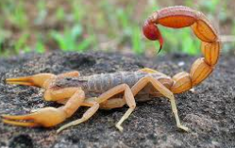
P4C

The Frog and the Scorpion

One day, a scorpion needed to get across a river to reach her family, but scorpions can’t swim. She saw a frog swimming in the river and asked if he would help her across. The frog replied, “You’re a scorpion and scorpions sting frogs!”

The scorpion replied, “But I need your help, so I won’t sting you today.”
“How do I know that you won’t sting me when you are on my back?” asked the frog. The scorpion reassured the frog that it would make no sense for her to sting him as the frog would drown and so would she.

After carefully considering it, the frog agreed and so the scorpion climbed on his back and they set off across the river. Roughly half way across, the frog suddenly felt a sharp pain in his side. He realised that he had been stung by the scorpion and managed to say with his last breath, “Why did you do that? Now we are both going to drown!”
The scorpion replied, “ I can’t help it, it’s in my nature!” And with that, they both sank to a watery end.

What is blame?
When is something somebody’s fault?
Is fault the same as ‘responsibility’?
If you can’t help doing something, is it your fault if you do it?
Did the scorpion really mean it when she said she wouldn’t sting him and she would try to override her instincts?
If she really meant it when she said it, does that mean that she didn’t break her promise until instinct took over?

