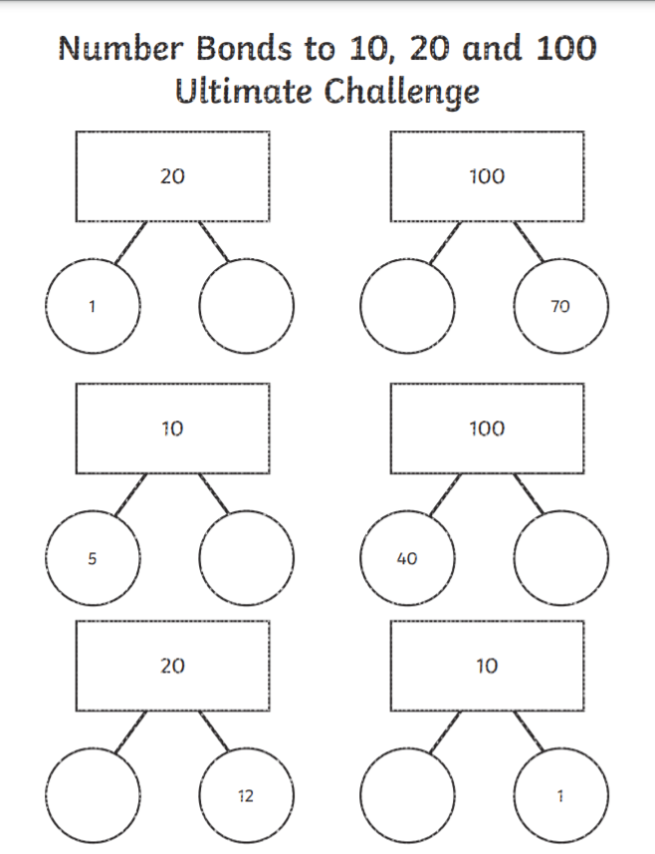

**This weeks homework is to revise our number bonds. The two numbers at the bottom when added together will equal the number at the top of the triangle.**

**For example one:**

**1 + __ = 20**

**1 + 19 + 20 Therefore 19 goes into the blank circle. If you have completed all of the questions, challenge yourself by drawing your own examples, try drawing 5 but if you can do 10. Good luck!**

